**DBMS ASSIGNMENT 6**

**CLASS: TE B**

**ROLL NO: 322008**

**Problem Statement:** Write a PL/SQL block of code using parameterized Cursor, that will merge the data available in the newly created table N_RollCall with the data available in the table O_RollCall. If the data in the first table already exist in the second table then that data should be skipped.

**Screenshots:**

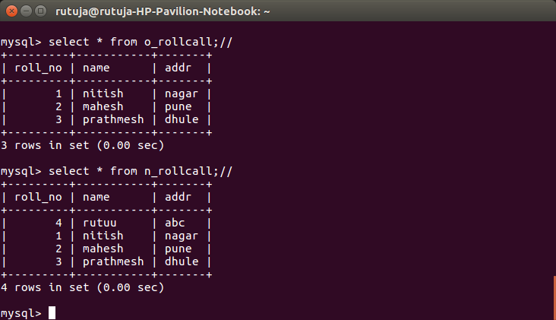

**Queries:**

1. Select * from o_rollcall;//
2. Select * from n_rollcall;

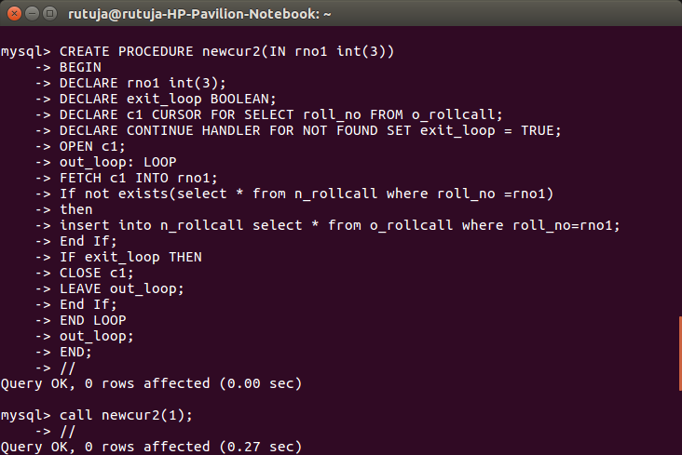

**Queries:**

CREATE PROCEDURE newcur2(IN rno1 int(3))

BEGIN

DECLARE rno1 int(3);

DECLARE exit_loop BOOLEAN;

DECLARE c1 CURSOR FOR SELECT roll_no FROM o_rollcall;

DECLARE CONTINUE HANDLER FOR NOT FOUND SET exit_loop = TRUE;

OPEN c1;

out_loop: LOOP

FETCH c1 INTO rno1;

If not exists(select * from n_rollcall where roll_no = rno1)

Then

Insert into n_rollcall select * from o_rollcall where roll_no = rno1;

End If;

End LOOP

Out_loop;

END;

//

Call newcur2(1);

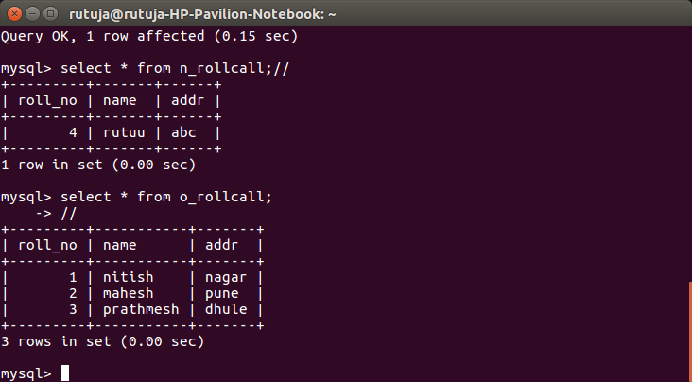

**Queries:**

1. Select * from o_rollcall;//
2. Select * from n_rollcall;

**Conclusion:** Pl/sql block was implemented successfully.